**Drafts**

During the design studio my first idea was to work with multiple brushes to allow the user to select multiple time ranges to compare. Therefore I based most of my draft visualizations on this idea.

Visualization A

Allows the user to select two areas using two brushes to compare.

The countvis will than for each question show two bars next to each with the number of votes for each question during the selected time spans. On top of these sets of bars, labels show the growth rate from one timespan to another.

For each set of bars a line will show the average number of votes for each question during the complete timespan that is available in the dataset.

Visualization E

Also features two brushes for selecting, but ranks the questions in a table. The table shows the ranking based on the timespan selected by brush 2. It shows the difference in votes from brush 1 to brush 2 as a field in the table. It also shows how the ranking of the questions changed from the brush 1 to brush 2 selections in parenthesis after the ranking indicator (for example +1 rank). Furthermore it shows the average number of votes for each question during the complete timespan that is available in the dataset as a table field.

Visualization D

Only employs one brush for selection and shows for each question using line charts, the trend of how the number of votes for the individual question development during the selected time frame.

Visualization B & C

Are based on feedback from a TF during the design studio and show alternatives of comparing data from two different times to showing two barcharts next to each other.

One option is to show two charts, with the second chart mirrored on the x axis.

Another option is to only show one bar for each question that only shows the difference between the number of votes for a question between the two selected timeframes. So if the difference is negative, the bar will extend below the x axis.

Visualization D

I decided to implement Visualization A with an average line that shows

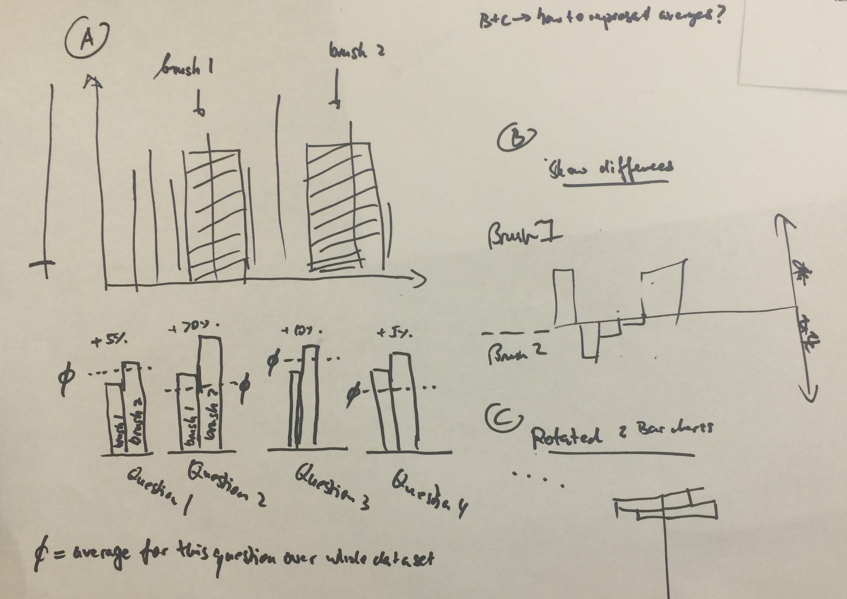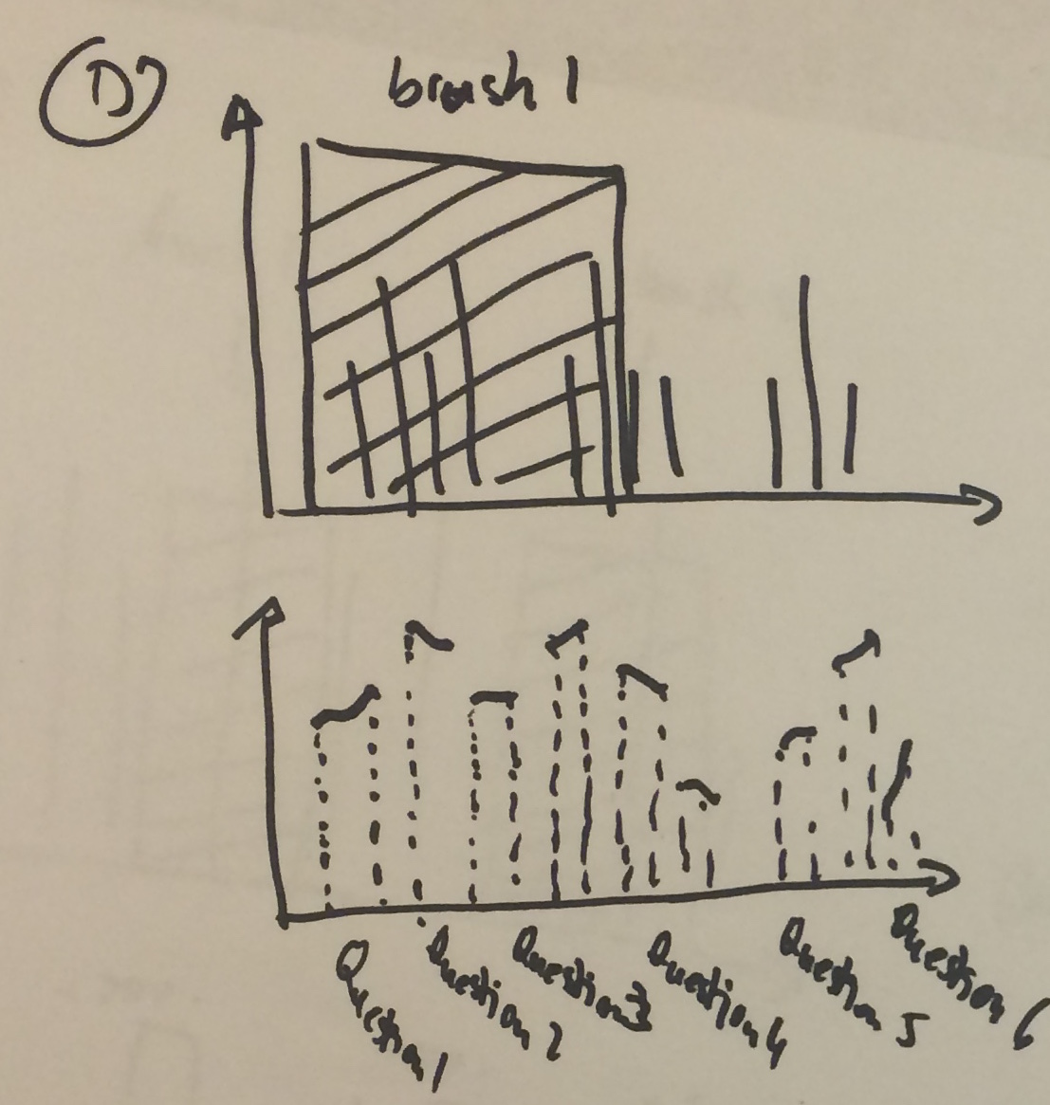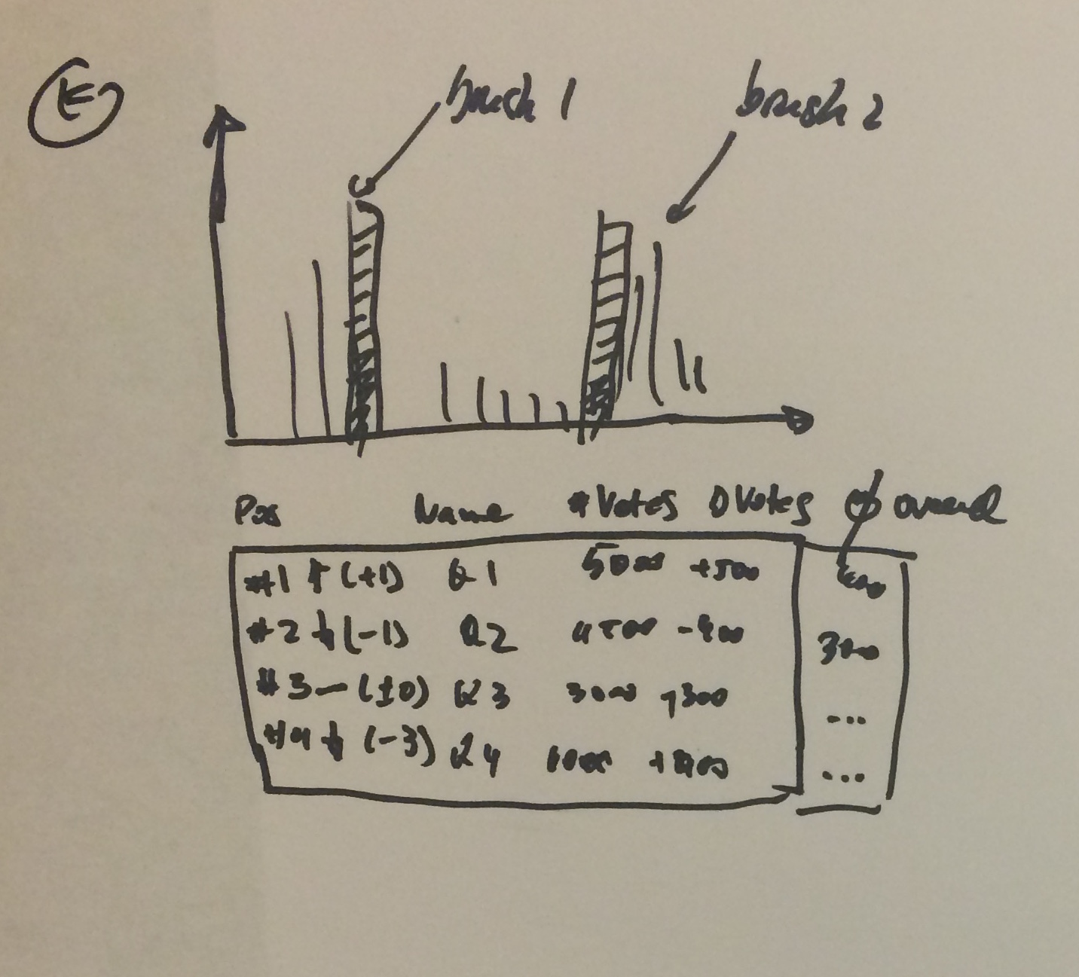

**Selection**

**Implementation**

- check calculating of averages (brushes)

- show priovis percentage instead?

can not move brush call to separate function

- errors in agevis data ("age" 2009, etc.)

- handling of ages > 100 ok?

- video or image als formatting template? (axis, ticks, etc.)

- normalize agevis?

－ Zooming does not work

</pre>

<pre>

- had to patch external lib multibrush to only allow 2 brushes max

- instruction > click outside of brush without moving mouse to reset brushes

- normalize data

- handling of outlines/erros in agevis

- brush labels because otherwise confusing

- agevis and multibrush

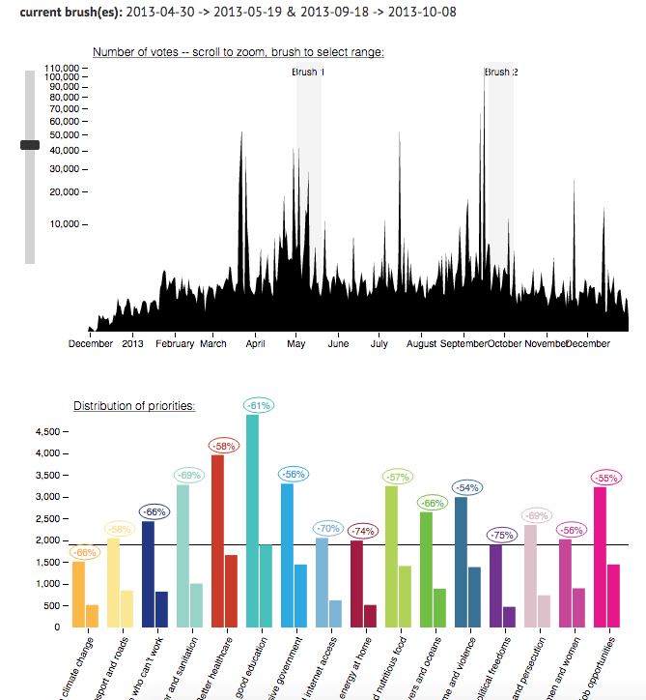

Pattern